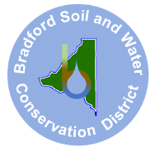Bradford Soil & Water Conservation District
2266 Temple Avenue
Starke FL 32091
www.bradfordsoilandwater.org
(904) 966-6224

DRAFT
Minutes April 1, Meeting
Meeting called to order 4:38 p.m.
Bradford Agricultural Center, Starke, Florida

Attending: Supervisors; Ok Sun Burks, Amy Morie, Walt Westcott. Guests, Paul Stil, Vicky Sweat by Zoom, Joanne Tremblay.

Motion by Ok Sun Burks to approve previous minutes with correction of adding Paul Still as a guest. Walt Westcott seconded. Motion approved by vote of 3,0.
Motion by Walt Westcott for Amy Morie to write a formal request to the BOCC to hold a workshop facilitated by BSWCD regarding Bradford County wide flood issues. Ok Sun Burks seconded. Motion approved by vote 3,0.

The meeting adjourned at 6:15 p.m.

Minutes submitted by Ok Sun Burks, secretary.

